**Experiment No # 02**

**Experiment Name # Basic Commands in Linux Mint.**

**Aim and Objects:**

The Linux operating system used for the PARTICLE DAQ system .That can be used either in a terminal mode where we can type commands or in a Windows Explorer style graphical user interface (GUI). We can specify commands to run. The terminal outputs the results of those commands :

**Linux Commands:**

We have to use the Terminal to write commands. the basic commands that are useful when working with files and directories are given below :

1. $ whoami : It shows who logged on this system

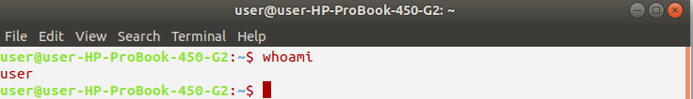

1. $ hostname : It tells on which machine you are

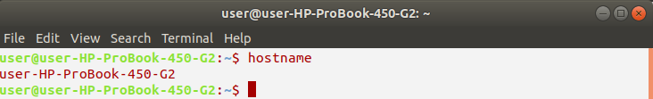

1. $ pwd : shows the path of current working directory

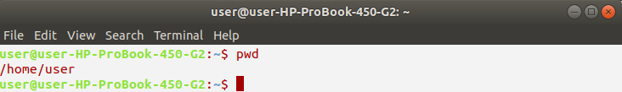

$ ls : displays the list of files in the current working directory

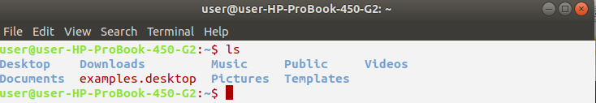

1. $ cd <dir_name> : switches to 'dir_name' directory

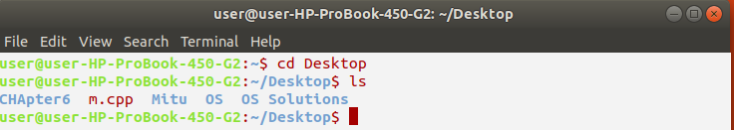

1. $ mkdir <dir_name> : creates a directory with specified 'dir_name'

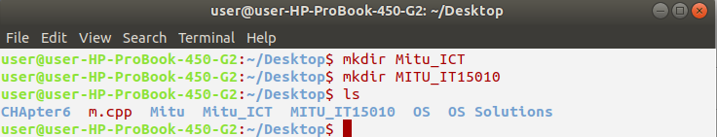

1. $ cd .. : moves one directory up

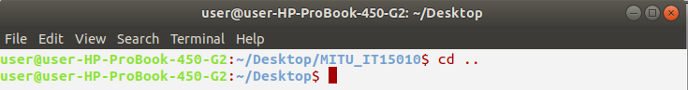

1. $ cd ../ ../ : moves two directories up (and so on)

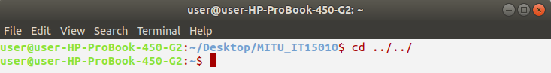

1. $ cd : brings you to the highest level of your home directory

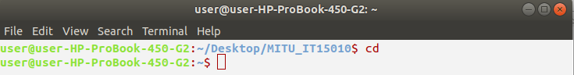

1. $ mv <name1> <name2> : renames the directories or files

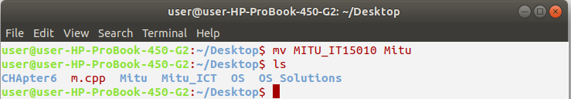

1. $ rmdir <dir_name> : removes entire directory

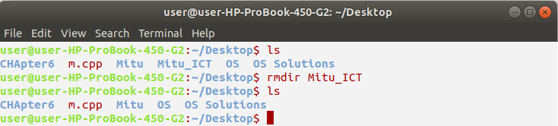

**Conclusion:**

For most of the time we can access a cloud server, we'll be doing it through a terminal shell. The shell allows to execute commands on the droplet. All administrative tasks can be accomplished through the terminal. This includes file manipulation, package installation, and user management. The terminal is interactive. Executing any command is done by typing it and pressing Enter.